Your contact person:

Klaus Müller
Marketing

Head of Communication

Telephone +49 9341 86-1125
Fax +49 9341 86-1411
Klaus.Mueller@weinig.com

February 2017

Date

PRESS RELEASE

The Weinig Group at LIGNA 2017:
Digitized production at the customer's service

LIGNA 2017 will open with a new space concept. This means that, for the first time, the Weinig Group will be presenting its complete range for solid wood and panel processing in Hall 27. The 4000 m² stand will provide customers with a unique offering for small business and industry under the motto “THINK WEINIG”. The solid wood processing area will present the product range from the planing and profiling, cutting and optimization, jointing technology and window & furniture production segments. W 4.0 Digital, project business and alternative materials will all be under the spotlight.
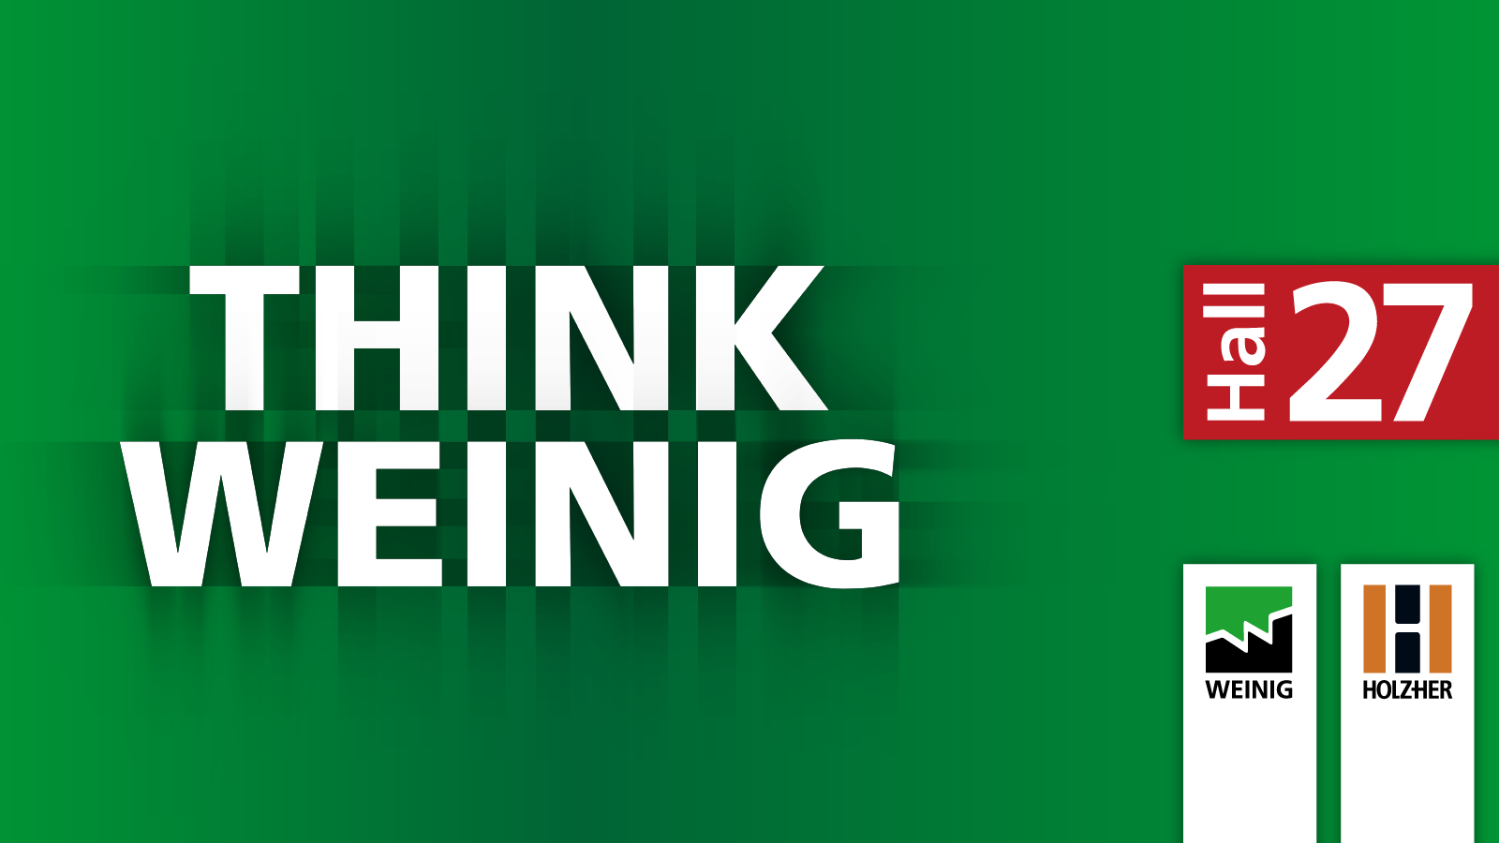

All 40 Weinig Group exhibits will be demonstrated live. Another first in Hanover will be the group's joint presentation with the business unit Panel Processing. Holz-Her will be exhibiting solutions for CNC processing, panel splitting and edge banding on the Weinig Group stand as well as presenting panel storage systems.

Customer benefits are the primary advantage
Industry 4.0 is the key megatrend in the wood industry. However, as Chief Sales and Marketing Officer Gregor Baumbusch underlines: “Digitization for its own sake does not give you a competitive advantage. Our solutions are always targeted towards customer benefits.” Efficient and resource-saving planning and production as well as intelligent maintenance run like a common thread through Weinig's networked production solutions, also known as W 4.0 Digital. All solutions are tailored towards providing the customer with the right information at the right time and in a user-friendly manner. This applies equally to industry and small business, which are increasingly difficult to differentiate.
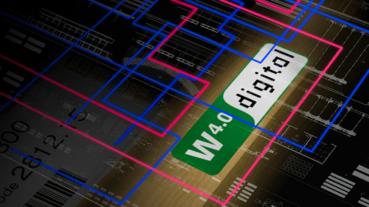

Future-oriented production with the Weinig Group

- Simplification: Making complex processes manageable
High-tech solutions place high demands on operating personnel. If businesses are to remain fully operational at a time when qualified personnel remain scarce, operation of complex production systems must be kept as simple as possible. Hence, simplification is a central challenge for manufacturers. At the heart of this are expert systems that support personnel via the screen and eliminate malfunctions. Weinig creates optimal working conditions via user-friendly control systems. OptiCom/Plus software, used in all machines and systems from the product unit Cutting, provides a uniform user interface. Exhibits from the moulder segment will be equipped with the optional SmartTouch set-up aid.

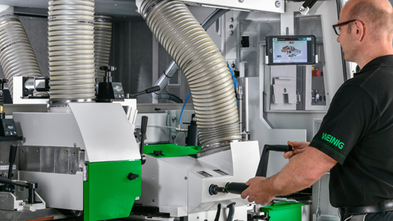

Monitoring sensors prevent collisions in the machine and other severe damage. On the Powermat 1500, the Vario hood assists with the adjustment of the pressure elements. Making its LIGNA debut, the ProfiPress T Next Generation uses automatic wood thickness setting to avoid defects in the panel press. In the Weinig scanner segment, the new automatic camera adjustment reduces operating errors and their effects to a minimum. The new Weinig EasyStop, meanwhile, makes entry into the automation of manual processing machines relatively easy. The cutting list is prepared in the office. Alignment of the work pieces on the longitude fence is designed to be extremely convenient. Last but not least, our compact four-sider Cube Plus, which will also be presented on the LIGNA stand, is an outstanding example of a successful concept when it comes to simplification. The intuitive operation makes planing simpler than ever and is ten times faster than using a jointer and thickness planer.

- Resource efficiency: Reduce costs and produce more profitably
With the cost of personnel, raw materials and equipment on the increase, resource efficiency will become increasingly important in production. This is where optimization can play a decisive role. Scanner systems for quality assessment and sorting will surely also soon be standard in smaller operations.

The key to success is digital order preparation on the PC. In Moulder Master, Weinig offers a software package for the perfectly organized working environment. In conjunction with the new fully-automated Rondamat 1000 CNC tool grinding machine, OptiControl Digital tool measuring stand and PowerCom Plus controls, Moulder Master offers a system that enables process stages to be linked from the idea to the finished profile and allows the next tools and profiles to be prepared in parallel with the production in progress.
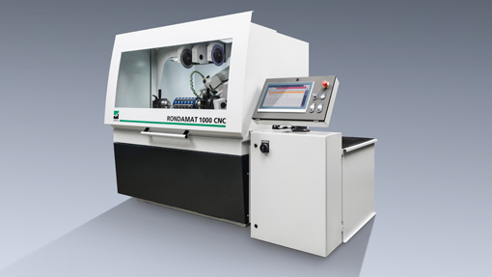

Cross-cut saws, meanwhile, use the OptiPal Weinig software package. This enables intelligent cutting list creation for pallet and crate production and will also be exhibited in Hanover. In Millvision and Envision, the Weinig Group offers additional software components for digitization of production stages. Based upon Weinig and Holz-Her technology, these offer the opportunity to network all processes from incoming orders to cutting to the finished product.

Wood optimization raises profits and, in the Weinig Group, starts with the OptiCut S 50 pushfeed saw. New features include the alignment aids for packages to increase length accuracy and fully-automated work piece recognition. The larger OptiCut S 90 Speed now has a servo spindle stroke for tear-free cutting without refinishing. The new wFlex unit will also be on display in Hanover via an animation and enables length and width cutting in a single work stage. At the top end of the Weinig performance spectrum, the OptiCut 450 Quantum is the fastest optimizing cross-cut saw in the world. The current version impresses with the VarioStroke automatic adjustment aid, which enhances performance by up to 7% and, in OptiStat, includes a new tool for evaluating production data. The OptiCut 260 and Weinig EasyScan⁺ four-sided color scanner make a formidable duo for high-performance defect removal. A new feature on the saw is the servo waste shaft, which also ensures reliable part separation during sorting in high-speed operation.
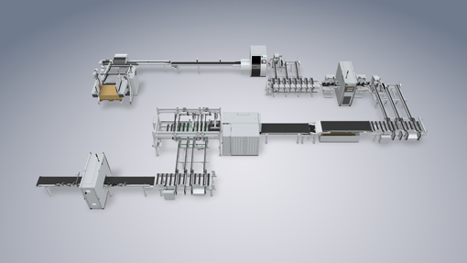

The EasyScan⁺ C includes high-performance optimization software for particularly high recovery. The price-performance ratio has been further enhanced by focusing on the most important functions and rigorous reduction of the options.

In RipAssist, the Weinig range includes a system for optimized width cutting in the rip saw segment. This can be seen live in action at LIGNA on the VarioRip 310 M multi-blade buzz saw. The cutting exhibits in Hanover will be completed by the robust BKS band resaw with automatic width measurement and bevel cut device.

Efficient wood finishing via finger jointing is a further area of optimization traditionally served by the Weinig Group. The range extends from the short-timber solution to the high-performance finger-jointing line in the long timber segment. The Turbo-S 1000 patented shaper combination will be on display in Hanover. The system achieves maximum wood recovery via automatic chip removal settings and the use of a Trimsaver and meets the highest performance demands with 15 press cycles per minute. Glue application monitoring ensures lower operating costs. The capabilities of the Turbo-S 1000 will be demonstrated at LIGNA via a linked production line, which will also include the OptiCut 450 Quantum high-speed cross-cutting system. To complement the finger-jointing range, the Weinig Group product spectrum also includes the Rondamat 985, a grinding machine for fully-automated sharpening of finger-jointing cutters. Weinig subsidiary Grecon will also be represented on the stand with the ProfiShape T4P double-end tenoner, which is specially designed for the formatting and flattening of frame components as well as profiling of a tongue and groove profile on MDF panels. The machine achieves an output of 40 parts per minute. Further products will be available for live demonstration at the nearby Grecon plant in Alfeld.

- Flexibilization: The right solution for every challenge
Today, modern production systems must be capable of creating single-item batches and industrial series production equally profitably. At the same time, processes and working methods industry and small business are merging. Consequently, operations require variable, modular systems based upon leading-edge technology.

The Weinig Powermat world
In the Powermat, Weinig has created a modular system that fulfills these precise requirements. The new Powermat 2400 will celebrate its world premiere at LIGNA. The moulder is designed for industrial bead production at feed speeds up to 100 m/min and will be demonstrated in a mechanized process with charging and discharge. The 3D version can produce freely-programmable structured surfaces during throughfeed. A new feature is the facility to produce work pieces with conical or curved contours on the machine. For newcomers to the world of Weinig profiling, we have the Powermat 700 Compact. A window version is available in the same performance category for planing scantlings and profiling mouldings. On the next level, the Powermat 1500 is available in a wide range of variants covering various requirements and applications. Whether producing different widths with a mobile spindle or small batch sizes on one and the same machine, the Powermat 1500 is a moulder for all occasions. The Powermat 2500 SP splitting unit equipped with kerf saws for separating lamellae, as used in central layer production for example, completes the Weinig Powermat world.

The Weinig Conturex world
The second generation of the successful Weinig Conturex system comprises a wide range of CNC centers for window and furniture production, all of which are based upon the same principle of the patented clamping table. The modular machines range from the compact to the twin-track system solution with parallel processing of two work pieces. A master computer control system can network any number of axes and facilitates an almost limitless production system with optimal flexibility down to single-item batches. The seamless connection to all standard sector software opens up the Weinig Solid Woodwork Flow (WF) system to a wide variety of working environments. Pre-planing, wood optimization and extensive automation are now incorporated by Weinig as a matter of course and, together with the Conturex, form a highly-efficient production cell Until now, the CNC center has been predominantly used in window production.

At LIGNA, Weinig will demonstrate how perfectly Conturex technology, with its high performance capacity and flexibility, is suited to modern complete processing of furniture. New features on the integrated, highly productive Conturex C 125 Vario include the infeed mechanization with parallel charging, the 4 Vario single-clamp tables, each with two clamps and the two interpolating 5-axis heads.

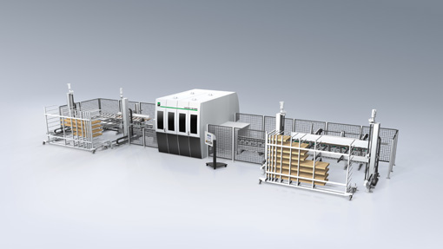

To demonstrate the high flexibility of the Conturex technology, furniture parts and transom/mullion constructions as well as window and door elements and folding shutters will be produced live on the networked system. The demonstration will include the Weinig Multirex 7225 Windows, a machine with a multi-functional head for efficient five-sided processing of solid wood elements. The new PRO-Torque technology allows highly precise 5-axis simultaneous milling motion.
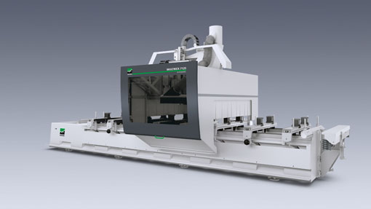

The system also incorporates the UniPin 200, a new machine for automatic window-sill gluing and driving in of dowels. The UniPin 200 particularly impresses with its even glue application. This lays the foundation for strength and tightness of corner joints, contributing significantly towards the quality of the end product.

- Smarttech: Maximum transparency of processes
The networked systems of the future demand an integrated software solution from idea to finished product. Only this can guarantee maximum transparency of processes. Work piece recognition via QR code, barcode or RFID are important aids. The operator benefits from short throughput times and elimination of sources of error. In Hanover, the Weinig Group systems and numerous machines on display will be equipped with corresponding systems. On the Powermat, part recognition supports highly precise processing when it comes to 3D structuring. The cross-cut saws at LIGNA will use fully-automatic work piece recognition combined with the application of high-resolution logos.

- Monitoring and predictive maintenance: an insight into your own production
Maximum availability of machines and systems is a top priority for customers. Hence, optimal production planning and control are essential, as is regular information on service intervals, tool service life and usage. Modern machine monitoring tools and maintenance systems are capable of delivering all of this. Weinig will demonstrate this connection to monitoring at LIGNA using running machines. This will include a demonstration of production monitoring in window production on the Conturex CNC center. As a practical example, the newly developed spindle monitoring can be seen in action with Weinig customer KGM. This allows the spindle temperature to be monitored and reports any violations of the threshold value. Also in Hanover, we will be demonstrating the various possibilities offered by the Weinig Service App. The integrated live window, for example, allows machine problems to be identified, service inquiries to be initiated or down times to be reduced regardless of your location.
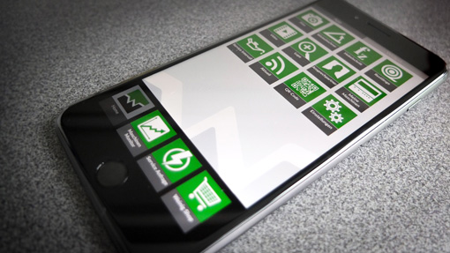

- Integration: Production cells increase productivity
Standalone machines are largely consigned to history. Integration, therefore, is a key concept in modern production. One data set is sufficient to network a wide range of components in a production cell together. Master computer technology makes it possible to cover the most complex processes. Even now, for example, it is possible to cover several hundred axes in window production.

At LIGNA, the Weinig Group will be presenting production cells of wide-ranging complexities for a broad spectrum of demands under our unique selling proposition “Everything from a single source”. The compact FlexiRip / FlexiCut cutting center links a universal multi-blade buzz saw with a cross-cut saw. Fully-automated, 2D-optimized ripping, on the other hand, is the central theme of the large cutting system on the Weinig stand. The system comprises a ProfiRip 450 M4 Speed multi-blade buzz saw with roller feed, an EasyScan RT scanner for defect detection, cross-section visualization and a printer for marking mouldings. The networked production line represents uncompromising high-speed production in line with the promise “Making more out of wood”, combining the entire expertise of the Weinig Group in a highly-efficient solution. The line networks together a scanner, an optimizing cross-cut saw and a finger-jointing line. Communication on the W4.0 Digital standard ensures that the system is completely open to the future of production.

Gluing: Two LIGNA premieres
Two machines not incorporated into a production line but that can be integrated at any time will also celebrate their premieres in Hanover. One is the new ProfiPress T Next Generation. The automatic gluing press is a newly developed machine from the ground up and achieves 25 per cent more output. The leap in performance is principally attributable to the faster packaging and increased high-frequency entry. The so-called selective heating also plays a central role. During this process, the joint is only heated from the inside, resulting in shorter press times among other benefits.
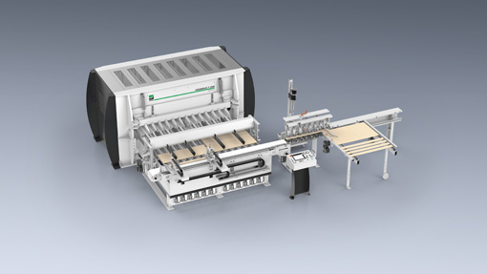

Meanwhile, “Making scantlings the fast and easy way” is the motto of the ProfiPress L B, which also makes its world premiere. New features of the high-frequency press include cylinders that can be switched off, ensuring short auxiliary processing times. Special top pressure ensures the lowest possible height offset. A press cylinder that extends synchronously avoids length offset.

- System expertise: The power of innovation across the group
A central feature of Weinig’s appearance at LIGNA will be project business. The WEINIG Concept business unit, which brings together the entire expertise of the Weinig Group, will present four current activities.

One is a production line for formwork girders for the construction industry. Particular features include the flexible system size and the opportunity for individual adaptation. This allows customers to implement a wide range of concepts using Weinig technology depending on performance requirements, available space and budget.

The second project is the butt-joint block gluing, which was awarded the Schweighofer Prize. The system is now available in three performance classes, ranging from an entry-level solution for small businesses to the highest level of equipment. Block gluing impresses with its high degree of flexibility, increased yield and high product diversity, among other features. The concept can be seen live in Hanover with a one-sided cycle press in a virtual tour.

We have also recently completed a system for layer production for one of the largest CLT production lines in Europe. At LIGNA, we will present the material flow and highlight the overall expertise of the Weinig Group across the entire value chain.

The fourth activity that will be presented is the palm oil wood research and development project. In conjunction with partners, we have successfully completed some basic tests regarding the machinability of the material. In recent months, Weinig Concept has transitioned to manufacturing products such as solid wood panels, 3-layer panels, panels with various coatings (veneer, MDF, etc.) as well as press boards. The status of this project will be documented at LIGNA.

The Weinig Group: Everything from a single source
“Weinig offers more” is not merely a slogan. It is an unconditional promise when it comes to quality, reliability, value creation and consultancy services. Everything from a single source. Consequently, we will be dedicating ample space to our comprehensive range of services at LIGNA. Weinig specialists will be on hand for customers throughout all four days of the trade fair, answering any questions covering the Pre-owned Machines, Service and Finance segments.

Photos:
The motifs incorporated into the text can be downloaded from the Weinig website in print quality at http://www.weinig.com/de/weinig-gruppe/presse-portal/.

